Open Eclips or STS

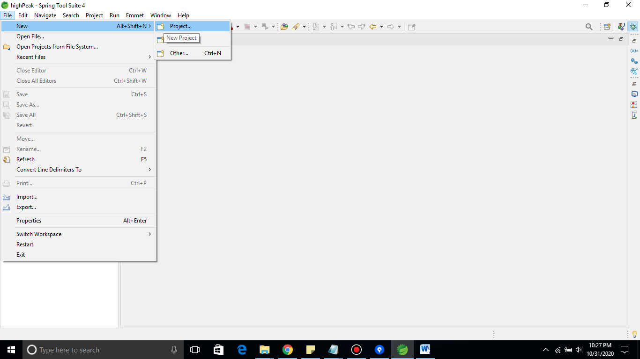File -> New -> Project

Search for java project and select it.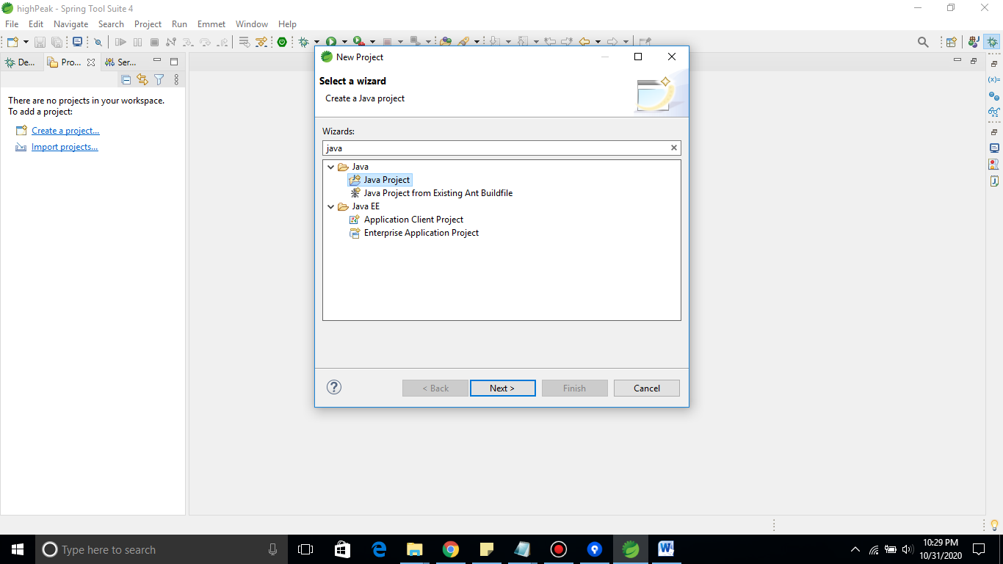

Give any name to Project Name

For example: assignment solution

Next click finish button

Create a Class name with 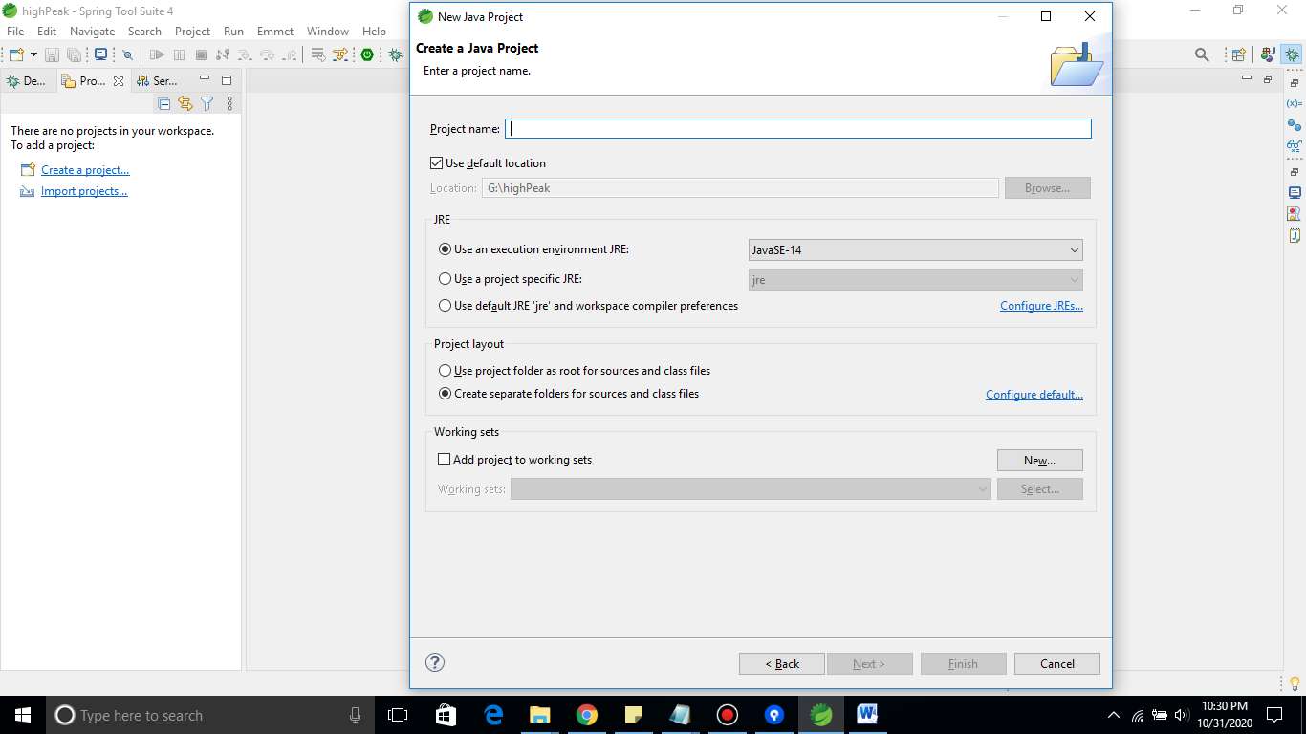SelectGoodies

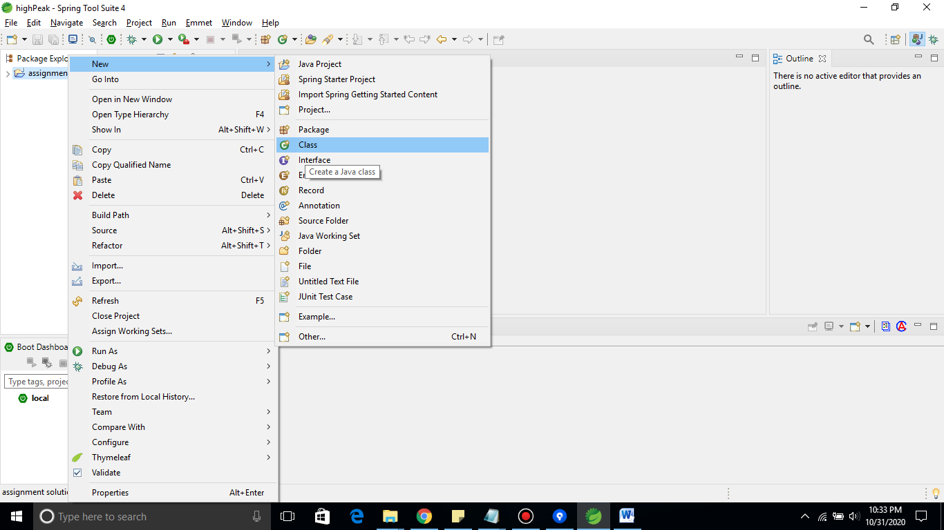

Copy and paste my code and run it as shown in screen recorder.